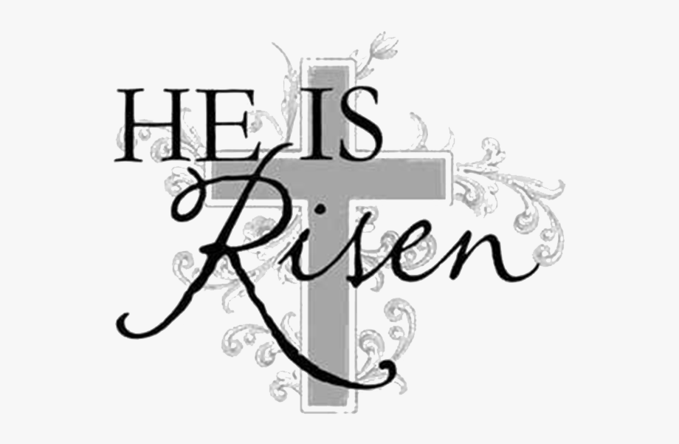

## St Joseph’s Carrickmacross St Michael’s Corduff St John’s Raferagh

**Fr Shane Mc Caughey** PP 042-9664367 **Fr Kevin Connolly** CC 0873493301 ( ***No texts messages to this mobile , call only*** ) **Parish Secretary: Yvonne Mc Bennett** Parish Office 042-9661231 : **Office opening hours** : 10am- 12.30pm Monday- Friday . **Email** [**stJosephscarrickmacross@outlook.com**](mailto:stJosephscarrickmacross@outlook.com)

**Website:** [**www.carrickmacrossparish.ie**](http://www.carrickmacrossparish.ie) **Webcam – Live streaming:** This can be viewed by our own webpage [https://www.carrickmacrossparish.ie/our-parish/web-cam/](http://click.accelo.com/ls/click?upn=F705whivLCzitx43dYBoC-2BbpVaj2VC-2ByUg7vvtDVPf6kFCF8sodeivqP8JVV-2BClLYInSeRPhnTr4bhfDRGQ6rw-3D-3DVOjt_rLLhlT0c7VL-2FEoxTkukWaQ4MPhvmVWN43dY62PEd8EaY4TWgPhCoWRHtiaSkjlsdvvkc6OK9GD2ICztKmmmppraQosFGRsVij6vg7n1htba2IAcOUjN4CqJmxrUlu3GDAt2mfWEGcoXppaKf0-2Fq5-2FDFKHj5pFGz1TNNTKzE9tzqWpQzhezUzjdGDURwoTntLrFHedzgKevNARMZkzD1GuW1jFfo-2FPtDLvR5YJxuSmEsFou6RoQ-2Bsx90XHTpLPufLOnf-2BkBZeYd214QloRwRWkbkrv70WZd9gOCV-2BdTlgn4nLHFN9mpwOcJRdZ4R4jVjI) or [www.churchservices.tv/carrickmacross](http://www.churchservices.tv/carrickmacross)

**Should you have any difficulty accessing the live streaming please contact via email directly to** [**Support@churchservices.tv**](mailto:Support@churchservices.tv)

**St Vincent De Paul : St. Vincent De Paul Contacts- Local Helpline (087) 917 1371**

**Easter Sunday - 17th April 2022**

|  |  |  |
| --- | --- | --- |
| **Weekly Reflection**  **“Person – to – person!”**  The Resurrection of Jesus is often described as the most significant event in the history of humanity. If it is, then it does not seem to have been terribly well organised. As any event organiser knows, the success or failure of a project is dependent on having a strategy in place to get people informed.  The story of the Resurrection falls down on this. On the first Easter morning there was confusion with nobody seemingly aware of what was happening. Mary was at a loss at the empty tomb so she went to Peter thinking he’d know, but he knew nothing either, and after much running around all that could be said for certain was that the tomb was empty. Even a week or more later the Apostles were still not convinced with poor Thomas achieving notoriety for his own lack of belief. It was Pentecost before the Apostles came to terms with the Resurrection and then they started to tell the world. With all the confusion, shock and doubt, the communications strategy seemed to be dire, the Resurrection should really have been described as a non-event.  And yet the strategy that God had put in place has proved to be exceptional. The announcing of the Resurrection was simple – tell one person at a time! This formula continues today, our faith is handed on by the telling and retelling of the story from parents to children assisted by our schools and our parish communities. It is our responsibility to continue to talk about Jesus, for society would often prefer not to know. This is our Faith, we are proud to profess it. ( Fr Shane) | | |
| **Saturday 16th April,**  **Holy Saturday** | |  | **Holy Saturday**  **Easter Vigil  in St Joseph’s Church 9pm** | |
| **Sunday 17th April**  **Easter Sunday** | |  | **Easter Sunday**  **Mass of the Resurrection at 9.30am &12 Noon** | |
| **Sunday 17 April**  **Easter Sunday** | | **9.30am** | Maureen Mc Geee, Dunogue; Colm Duffy and his Mother Mary, Mullinary. | |
| **Sunday 17th April** | | **12 Noon** | **M.M. Noel Mc Mahon, Mullinary** ; Luke Brennan and Thomas and Elizabeth Callan , Drumgowna; Dave Ryan Creevy, Carrickmacross; Malachy Boyle, Castleblayney Road and deceased members of the Boyle, Donaghey and Finnegan families; The deceased members of the Caulfield and Slevin families and Baby Cian. | |
| **Monday 18th April** | | **10am** | **The People of the Parish** | |
| **Tuesday 19th April** | | **10am** | **Weekday Mass** | |
| **Wednesday 20th** | | **10am** | Harry Mc Mahon Scotland | |
| **Thursday 21St** | | **10am** | Teddy and Molly Baldwin , Bridge Street, her daughter Frances Marko. | |
| **Friday 22nd April** | | **10am** | Gerry Beggan, Magheross , Carrickmacross. | |
| **Friday 22nd April** | | **7.30pm** | **M.M Jimmy Scotson, Carrickmacross**  **M.M Kevin Conroy, Beech Drive , Carrickmacross** | |
| **Saturday 23rd** | | **11am** | **M.M Macartan (Mac) Murphy, O‘Neill Street, Carrickmacross.** | |
| **Saturday 23rd** | | **6pm vigil** | Tony O’Kane, 3 Drummond Heights; Brendan and May Devine, the McDonald, Devine, Gorry and Fox families Monaghan, and the O’Neill family, Main Street; Deceased members of the hand and Keenan families, St Macartans Villas. | |
| **Sunday 24th** | | **9.30am** | Deceased members of the Pat Cotter Choir , and Annie Mc Mahon , formerly Donegal. | |
| **Sunday 24th** | | **12 Noon** | **M.M Brian Lennon, Ardee Road** Deceased members of the Woods family, 47 St Macartan’s Villas. May Woods and Phyllis Hoey Dundalk; Eileen and Patrick Hand, Ard Ross Avenue; Peter and Rita Cogan, Patrician Drive; Kathleen Smith, 35 Highfield, and her son Philip. | |

**Recently Deceased** Paul Rooney, Leitrim, formerly Magheracloone; Anthony Mc Veigh ( Snr) , Cormoy, Carrickmacross; Edward ( Ned) Burns , Corrinshigagh, Culloville, David Hughes, Dundalk

**Mass Time Corduff / Raferagh**

**Mass will be celebrated on Wednesday Evening at 7.30pm (alternating) * see updated schedule below for dates \***

**Sunday at 11am (alternating)**

**Live streaming is now available to be viewed Via**

[https://www.carrickmacrossparish.ie/our-parish/web-cam/](http://click.accelo.com/ls/click?upn=F705whivLCzitx43dYBoC-2BbpVaj2VC-2ByUg7vvtDVPf6kFCF8sodeivqP8JVV-2BClLYInSeRPhnTr4bhfDRGQ6rw-3D-3DVOjt_rLLhlT0c7VL-2FEoxTkukWaQ4MPhvmVWN43dY62PEd8EaY4TWgPhCoWRHtiaSkjlsdvvkc6OK9GD2ICztKmmmppraQosFGRsVij6vg7n1htba2IAcOUjN4CqJmxrUlu3GDAt2mfWEGcoXppaKf0-2Fq5-2FDFKHj5pFGz1TNNTKzE9tzqWpQzhezUzjdGDURwoTntLrFHedzgKevNARMZkzD1GuW1jFfo-2FPtDLvR5YJxuSmEsFou6RoQ-2Bsx90XHTpLPufLOnf-2BkBZeYd214QloRwRWkbkrv70WZd9gOCV-2BdTlgn4nLHFN9mpwOcJRdZ4R4jVjI) or [www.churchservices.tv/carrickmacross](http://www.churchservices.tv/carrickmacross)

**Should you have any difficulty accessing the live streaming please contact via email directly to**

[**Support@churchservices.tv**](mailto:Support@churchservices.tv)

**Mass Intentions**

|  |  |  |
| --- | --- | --- |
| **Sunday 17th April Corduff** |  | **Mass of the Resurrection in St Michael’s Church, Corduff at 11am**  Molly Sheridan and her deceased parents Francis and Rose; Pete and Katie Mc Bride , Coraghy, Shantonagh and the Burns family Lisacullen, Shantonagh; Tom Mc Nally , Greagh, Corduff , his parents Annie and Patrick, brothers Brian, Peter and Pat; Kathleen and Patsy Connolly, Greaghlane ,Corduff. |
| **Wednesday 20th April Raferagh** |  | **Private intention** |
| **Sunday 24th April Raferagh** |  | ***Special Intention;***  Teasie Mc Connon and her parents Pete and Alice, Farney Street, her sisters and brothers and all deceased members of the Mc Connon and Mc Enaney families. |

**Adoration of the Blessed Sacrament Corduff/ Raferagh**

Will take place ***each Wednesday evening*** in Corduff/Raferagh 5pm until Mass at 7:30pm.

**Adoration in Blessed Sacrament Chapel (St Josephs)**

The Blessed Sacrament Chapel opening hours are: Monday 9-10am, Tuesday 9am-7pm, Wednesday 9-10am, Thursday 9-10am, Friday 9-10am, Saturday 10-11am and Sunday 1-6pm.**.**

|  |
| --- |
| See the source image  **St. Joseph’s Triduum Theme *St. Joseph "A man of our Time".***  Come join in the celebration to St. Joseph the worker. Three days of prayer; believing, hope and love In St. Joseph's Church, Carrickmacross 27th, 28th, 29th April. **Mass each day at 10am, 7.30pm**.  **Thursday 28th- 7.30pm Mass and Healing Service.** |

**MIC Alumni Reunion 2022**: After an absence of more than two years we are delighted to announce the return of our Alumni Reunions with the next reunion scheduled to take place on the Limerick campus on Saturday June 18 from 2 – 5pm. This reunion will see us welcome back graduates from the following years: 1947, 1952, 1957, 1962, 1967, 1972, 1977, 1982, 1987, 1992, 1997, 2002, 2007, 2012 and 2017. If you wish to attend or would like further information, please email Alumni@mic.ul.ie

**Be Alert:** There continues to be fraudulent scams and alerts via telephone calls, emails etc. Please continue to be aware and cautious of any unexpected activity or communication to you and to your vulnerable family members.

**Possible Pilgrimage to Lourdes in 2022**: The Diocese of Clogher Lourdes Pilgrimage Committee is considering having a small pilgrimage to Lourdes later this year – in either late July or early August. This will be a more limited pilgrimage than usual and would not include assisted pilgrims, due to the Covid-19 situation. The cost of the proposed pilgrimage will be approximately €790 per person, based on two people sharing. In order to determine the level of interest, anyone interested is asked to contact John Hueston on +447841100055 or email at john.hueston@btinternet.com before Friday 22 April 2022.

**Liturgy Readers**

***(Existing and new)***

**A Readers refresher and training course will take place on the**

**11th May – 7.30 in the Shirley Arms Hotel**

There will be a follow up meeting 2nd Training evening **on the 24th May at 7.30pm in the Workhouse , Carrickmacross**

**We invite all existing and new readers to attend .**

*"Wishing our Faith Community, a Blessed and Happy Easter from Fr Shane & Fr Kevin , and all the parish team ."*